|  |
| --- |
| **Name: Debarghya Barik**  **Rg. No: RA2011026010022** |

**Session9**

# District Administration and the role of District Collector: Legislative, and Executive Control

District administration functions under the charge of a District Officer termed District Collector. District administration functions within the territorial boundary of the district. The government at the Centre and at the State level cannot implement its policies from the headquarters, the state is divided into territorial divisions and district level. The primary concern of the district administration is to ensure public safety, the protection of citizens and all their rights. It comprises the maintenance of law and order and the administration of criminal and civil justice. In the field of revenue administration its role includes land revenue, irrigation charge, agriculture income, tax levied, excise duties, entertainment tax etc. Along with these, the administration of treasury, land reforms, land acquisition, land management, land records, etc. also fall within the ambit of the district administration. The collector has to ensure the supply of essential commodities to the people living in remote villages. It collector’s responsibility to help people in times of natural calamities and disasters.

The District Collector or Deputy Commissioner, who as the chief representative of the government is the head of the administration. The foremost task of a District Collector, as the head of the revenue administration of the district, is the assessment and collection of land revenue. The District Collector’s Revenue Functions include, maintaining land records, collecting land revenue, rural statistics, government dues, distributing and recovering loans, implementing land reforms, looking after the welfare of the agriculturists., making an assessment of losses of crops and recommending relief during natural calamities like fire, draught and flood etc., paying rehabilitation grant, hearing appeals against the orders of lower authorities, managing government estates, paying Zamindari Abolition compensation, supervising treasury and sub treasury, enforcing Stamp Act. District Collector is also responsible for maintaining law and order in district, controlling and supervising the subordinate magistracy, Inspecting the jails,

The collector submits an annual criminal report to the government, controls and directs the action of district police; enforces Entertainment Tax Act and Press Act; grants, suspends or cancels various kinds of licenses like arms, hotels, explosives, etc.; orders disposal of unclaimed property supervises and controls local bodies; recommends schemes for the development of forests.

The collector conducts census operation every 10 years; functions as the returning officer and coordinator of election work of Parliament and Vidhan Sabha constituencies at district level; grants old age pension and house building loans; supervises and controls municipalities in the district. The collector functions as the chairman of several committees such as the family

|  |
| --- |
| **Name: Debarghya Barik**  **Rg. No: RA2011026010022** |

planning committee, public grievance committee, planning committee, soldier welfare fund committee, etc. and is responsible for the protection of ancient monuments.

**Task 1: Collect information about the various functions performed by the district administration in your home district and submit it as a case study. Include data, facts, and pictures to validate your statements. (20 Marks)**

**Ans:** There are **20 branches** which deals with various types of work wiped to them. In charge of each branch is an official of the rank of Assistant. **A citizen charter has been published and displayed on board in front of Mini Secretariat, KOLKATA**. In this citizen charter the nature of working of each branch in relation to public dealing has been shown and else elaborate the charge, Government fees to be deposited, procedure opted for accomplishment of work and the time frame feed for the one the rules and instructions of **the Government governing the working are contained in the District office Manual which maintained by the Superintended Deputy** Superintendent and is always available to the members of the public besides these instructions are revised from time to time which are readily available to public demand Act Tales have been maintained by all the branches as per requirement.

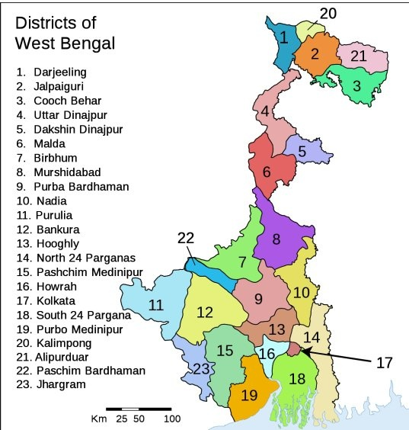

|  |
| --- |
| **Name: Debarghya Barik**  **Rg. No: RA2011026010022** |

Certified copies of the information are immediately supplied to the public on demand immediately. A separate register has been maintained for receipt and disposal of

applications under Right to Information Act, 2005. The information is supplied within the time frame fixed under the provisions of the Act. The following officers have been designated as State Public:

|  |  |  |  |
| --- | --- | --- | --- |
| S.NO. | STATE PUBLIC INFORMATION OFFICER | ASSTT. PUBLIC  INFORMATION OFFICER | JURISDICTION |
| 1. | CITY MAGISTRATE | SUPERINTENDENT/Dy. SUPDT, DC OFFICE | IN RESPECT OF  BRANCHES OF DC  OFFICES UNDER  HIS/HER CONTROL |
| 2. | SDM, KOLKATA | ASR o/o SDO | IN RESPECT WITH  THE BRACHES IN  SDO’s OFFICE |
| 3. | DISTRICT REVENUE OFFICER, KOLKATA | DEPUTY  SUPERINTENDENT  O/o D.C FARIDABAD | IN RESPECT OF THE  BRANCHES OF D.C  OFFICE UNDER  HIS/HER CONTROL |
| 4. | TEHSILDAR, KOLKATA |  | IN RESPECT OF TEHSIL OFFICE |
| 5. | NAIB TEHSILDAR, KOLKATA |  | IN RESPECT TO SUB TEHSIL OFFICE |
| 6. | D.D.P.O, KOLKATA | HEAD CLERK, PANCHAYAT | IN RESPECT OF THE DDPO OFFICE |

*Information Officer and Assistant Public Information Officer for this purpose*

|  |  |
| --- | --- |
|  | CITY MAGISTRATE (GENERAL ADMINISTRATION) |
| BRANCH  ESTABLISHMENT BRANCH  MISCELLANEOUS BRANCH  NAZARAT BRANCH  LICENSING AND  PASSPORT BRANCH  RECORD KEEPER  SMALL SAVING  CENSUS BRANCH | WORK |
| This branch mainly deals with posting and transfers of the staff of D.C office. It maintains service record of Officials and prepares bills for salary increments/TA Medical allow s. It also deals with disciplinary  cases against employees |
| This branch deals with law and Order, visits of VIPS, cases under public shows, public meeting. Priming presses, character antecedents of  newly entrant in service, training of officers and miscellaneous, matters. Case under cinematography Act. Various meeting with district officer & appointment of duty Magistrate. |
| This branch deals with disbursement of salary and other allowances to staff and making other payments on account of contingency  expenditures & arrangements of meeting of 1DC & Ministers etc.  Disposal of condemned Govt. Vehicle and Property under 25 Police  Act He |
| This branch deals with grant of arms license in district, other matters relating to verification of passport, explosives/petroleum act. |
| Diary, Dispatch and Library |
| This works deals with environment of small saving agents and work for promotion of small saving |
| Census work |

**Session10**

# Municipal Corporation, Municipalities, and the Mayor

Municipal Corporation and Municipalities are all Urban Governance Bodies. A Municipal

Corporation is to govern cities with a population of more than 100,000 people. Municipal Councils are for towns between 25,000 and 100,000 in population. Nagar Panchayat are for

|  |
| --- |
| **Name: Debarghya Barik**  **Rg. No: RA2011026010022** |

towns with populations between 11,000 and 25,000 people. They are all responsible, in their own way, to generate revenue through taxes and deliver services to the citizens. Their members are elected by the citizens. Number of members depends on the size of the city. There is chief officer with other councillors in municipality. Municipal corporation is ruled by IAS officer/ Mayor.

The mayor is the leader of the council and has legislative and functional roles. The mayor not only presides over all municipal proceedings within the municipality but must also take the chair at all meetings of the council at which he or she is present. Mayor’s important roles are leadership, promoting positive relationships, and modelling good governance. The mayor is usually council spokesperson and has a significant ceremonial role at specific events, including citizenship ceremonies. He or she is an important community leader and is often the spokesperson for the community on economic issues (such as commenting on the impact of jobs lost or gained in the municipality) or when the community is put under stress (such as disaster management and socio-economic issues). The mayor has responsibilities towards, and is accountable to, all councillors. And the mayor’s leadership style should reflect this.

**Task 1: Find out the names TEN Mayors governing Municipal Corporations in India currently. (5 Marks)**

## OR

**Task 2: Collect information about Municipal Corporations/ Municipality of your city/Town and enlist its functions. (5 Marks)**

**Ans:** The Municipal corporation of Kolkata is in Sector 18.The **functions** thatit implements are as follows:

* **Urban Planning** including Town Planning
* **Regulation** of **land use** including **construction of buildings.**
* **Prevention** of cruelty to animals.
* **Regulation** of **slaughter houses and tanneries.**
* **Public health**, sanitation conservation and solid waste management.
* **Fire Services.**
* **Urban afforestation** and promotion of ecological aspects.
* **Slum improvement** and upgradation.
* Planning of economic and **Social Development.**
* **Water supply** for domestic, industrial and commercial purpose
* **Urban poverty alleviation**.

|  |
| --- |
| **Name: Debarghya Barik**  **Rg. No: RA2011026010022** |

* **Promotion** of cultural, educational and aesthetic aspects.
* **Safeguarding** the interests of weaker sections of the society.

**Session11**

# Zila Panchayat, Gram Panchayat Block level governance

The Panchayati Raj Institution (PRI) consists of three levels:

* Gram Panchayat at the village level
* Block Panchayat or Panchayat Samiti at the intermediate level
* Zilla Panchayat at the district level

The word “Panchayat” means assembly (ayat) of five (panch) and raj means “rule”. Traditionally Panchayats consisted of elderly and wise people chosen by the local community, who used to settle disputes between individuals and villages. The leader of the panchayat used to be called as Mukhya or Sarpanch. Generally, the elder-most or most senior person would be elected to this position. The Panchayati Raj system is also recognised as a form of direct democracy (i.e they exercise all powers of a government at a village level), as opposed to the popular notion that it is a type of representative democracy.

Gram Panchayat: Gram Panchayat consists of a village or a group of villages divided into smaller units called “Wards”. Each ward selects or elects a representative who is known as the Panch or ward member. The members of the Gram Sabha elect the ward members through a direct election. The Sarpanch or the president of the Gram Panchayat is elected by the ward members as per the State Act. The Sarpanch and the Panch are elected for a period of five years. Gram Panchayat is governed by the elected body and administration. The secretary is normally in charge of the administrative duties of the Gram Panchayat.

Block Panchayat: Panchayat Samiti (also called Taluka Panchayats or Block Panchayats) is the intermediate level in Panchayati Raj Institutions. The Panchayat Samiti acts as the link between Gram Panchayat (Village) and District Panchayat (Zilla). These blocks do not hold elections for the Panchayat Samiti council seats. Rather, the block council consists of all of the Sarpanchas and the Upa Sarpanchas from each Gram Panchayat along with members of the legislative assembly (MLA), members of parliament (MPs), associate members (like a representative from a cooperative society) and members from the Zilla Parishad who are a part of the block. The Gram Panchayat members nominate their Sarpanch and Upa Sarpanch amongst their ranks, which extend to the selection of the chairperson and vice-chairperson as well. The Executive Officer (EO) is the head of the administration section of the Panchayat Samiti.

|  |
| --- |
| **Name: Debarghya Barik**  **Rg. No: RA2011026010022** |

District Panchayat: The District Panchayat also known as the District Council or Zilla Parishad is the third tier of the Panchayati Raj system. Like the Gram Panchayat, the District Panchayat is also an elected body. Chairpersons of Block Samitis also represent the District Panchayat. Like the Block Panchayat, the MP and MLA are also members of the district panchayat. The government appoints the Chief Executive Officer to carry out the administration of the district Panchayat along with the the Chief Accounts Officer, the Chief Planning Officer and one or more Deputy Secretaries who work directly under the Chief Executive Officer and assist him/her. The Zilla Parishad chairperson is the political head of the district panchayat. (Source: <https://pria.org/panchayathub/panchayat_text_view.php>)

**Question 1: What do you think could be the purpose behind establishing this third tier of**

**government? Reflect over it in minimum 100 words. (10 Marks)**

**Ans:** A vast country like India cannot be governed properly by **two-tiers** only. The**two-tier governments**are best suited for countries which are small but **India being a large country,**it would not have been easy to handle. Some states in India are as large as independent countries of Europe. Thus, there is a need of power sharing within these states, for which **third**-**tier of government** is created. The concept of three-tier came in existence in **1993 after amendment 73 and amendment 74 of the constitution.**

The **three tiers of government** are:

* The Union Government
* The State Government and
* The Local Government.

The Balwant Rai Mehta Committee recommended the establishment of the scheme of ‘democratic decentralisation’, which finally came to be known as Panchayati Raj, the third tier as the local government. This led to the establishment of a three-tier Panchayati Raj system: Gram Panchayat at the village level, Panchayat Samiti at the block level, and Zila Parishad at the district level.

The **local government decreases the pressure** on the state government. It includes **Panchayati Raj and Municipal bodies**for smooth functioning. They work under the state government and with their help organise various programs and policies for the benefit of the people.

|  |
| --- |
| **Name: Debarghya Barik**  **Rg. No: RA2011026010022** |

The third tier of the local government was created in India due to many reasons.

**1.** To overcome various issues at the rural or the local level.

**2.** Requirement leading to the establishment of primary health centres, primary schools, the supply of drinking water, drainage and construction/ repair of roads at local and rural levels.

**3.** Implementation of schemes for the development of agriculture and infrastructure, cottage and small-scale industries, and the opening of cooperative societies.

**Session12**

# Election Commission of India

Election commission plays a vital role in organizing elections. The most critical challenge before the Election Commission of India is to ensure free and fair elections in the country. Key functions of the Election Commission of India are are:

* To issue the Model Code of Conduct in every election for political parties and candidates so that the decorum of democracy is maintained.
* To regulate political parties and registers them for being eligible to contest elections.
* To publish the allowed limits of campaign expenditure per candidate to all the political parties, and monitors the same.
* The political parties must submit their annual reports to the ECI for getting tax benefit on contributions.
* It guarantees that all the political parties regularly submit their audited financial reports.
* The Commission can recommend for disqualification of members after the elections if it thinks they have violated certain guidelines.
* In case, a candidate is found guilty of dishonest practices during the elections, the Supreme Court and High Courts consult the Commission.
* The Commission can postpone candidates who fail to submit their election expense accounts timely.

|  |
| --- |
| **Name: Debarghya Barik**  **Rg. No: RA2011026010022** |

* To supervise, direct, control and conduct all elections to Parliament and State Legislatures as also to the office of the President and Vice- President of India.
* To set down general rules for election.
* To determine constituencies and to prepare electoral rolls.
* To give credit to political parties.
* To allot election symbols to different political parties and individual contestants.
* To appoint tribunals for the decision of doubts and disputes arising out of or in connection with election to parliament and State Legislatures.

**Task 1: Survey and write an essay on the General Elections 2019 in India. Narrate its entire process including phases in which it was held in different parts of the country, percentage of votes casted, number of candidates contested, results of the elections, interesting facts about these elections, presidents’ role, selection of PM, cabinet ministers, and several such relevant details. Submit it as handwritten assignments in A4 papers in not less than FIVE (both sides) pages. Pay attention to the conciseness, yet comprehensibility of your writeup. (20 Marks)**

**Ans: The Overview 2019 Indian general election**

The **2019 Indian general election** was held in seven phases from 11 April to 19 May 2019 to constitute the 17th Lok Sabha. The votes were counted and the result declared on 23 May. About 911 million people were eligible to vote, and voter turnout was over 67 percent – the highest ever, as well as the highest ever participation by women voters.

The Bharatiya Janata Party won 303 seats, further increasing its substantial majority and the BJP-led National Democratic Alliance (NDA) won 353 seats. The BJP won 37.36% of votes, while the NDA's combined vote was 45% of the 60.37 crore votes that were polled. The Indian National Congress won just 52 seats, and the Congress-led United Progressive Alliance won 91. Other parties and their alliances won 98 seats.

### **Party campaigns**

* 12 January 2019 – Prime Minister Modi launched the BJP's election campaign.

|  |
| --- |
| **Name: Debarghya Barik**  **Rg. No: RA2011026010022** |

* 14 February 2019 – The INC president Rahul Gandhi launched his campaign from Lal Dungri village in Gujarat's Dharampur.
* 24 March 2019 – The [Aam Aadmi Party](https://en.wikipedia.org/wiki/Aam_Aadmi_Party" \o "Aam Aadmi Party) began its campaign in Delhi.
* 2 April 2019 – The [Trinamool Congress](https://en.wikipedia.org/wiki/Trinamool_Congress) party launched its campaign from Dinhata, Coochbehar.
* 7 April 2019 – [Bahujan Samaj Party](https://en.wikipedia.org/wiki/Bahujan_Samaj_Party) and [Samajwadi Party](https://en.wikipedia.org/wiki/Samajwadi_Party) began campaigning together as an alliance) along with regional parties such as the [Rashtriya Lok Dal](https://en.wikipedia.org/wiki/Rashtriya_Lok_Dal" \o "Rashtriya Lok Dal).

**Party manifestos**

#### **Highlights of the Congress manifesto**

The Congress released its manifesto, titled ***Congress Will Deliver*** on 3 April.

* Introduce a Nyuntam Aay Yojana welfare program wherein ₹72,000 per year will be transferred directly to the bank account of a woman-member in each family in the poorest 20 percent households.
* Enact a Right to Homestead Act that will provide free land to every household that does not own a home.
* Preserve special status and special rights to natives of Jammu and Kashmir under Article 370 and 35A

#### **Highlights of the BJP manifesto**

The BJP released its manifesto sub-titled ***Sankalpit Bharat, Sashakt Bharat*** on 8 April.

* Double farmer incomes by 2022 by completing all major and micro-irrigation infrastructure projects, opening adequate markets and modern farm produce storage centres, implement minimum price supports for farmer produce, farmer loans and all-weather rural roads
* Double the length of national highways. Improve fuel quality by mandating 10 percent ethanol in petrol. Scale renewable energy capacity to 175 GW.

|  |
| --- |
| **Name: Debarghya Barik**  **Rg. No: RA2011026010022** |

* Electrify and convert to broad gauge all railway tracks.

### **Parties and Alliances:**

### ***Political alliances***

There were five main national pre-poll alliances. They are the **National Democratic Alliance (NDA)** headed by the BJP, **the United Progressive Alliance (UPA)** headed by the INC MGB, **Federal Front** headed by All India Trinamool Congress, and **the left front** of Communist-leaning parties.

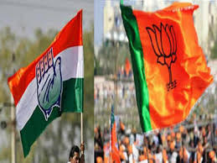

***Political parties***

More than **650 parties** contested in these elections. Most of them were small with regional appeal. The **main parties** are **the Bharatiya Janata Party (BJP)** and **the Indian National Congress (INC).**

### **Candidates:**

Altogether **8,039 candidates are in the fray for 542 parliamentary constituencies**. About 40% of the candidates fielded by Prime Minister Narendra Modi's Bharatiya Janata Party have a criminal case against them. Key opposition party Congress is not far behind with 39% of the candidates with criminal charges.

|  |
| --- |
| **Name: Debarghya Barik**  **Rg. No: RA2011026010022** |

**Voter Statistics:**

According to the ECI, **900 million people were eligible to vote**, with an increase of 84.3 million voters since the last election in 2014, making it the largest-ever election in the world.

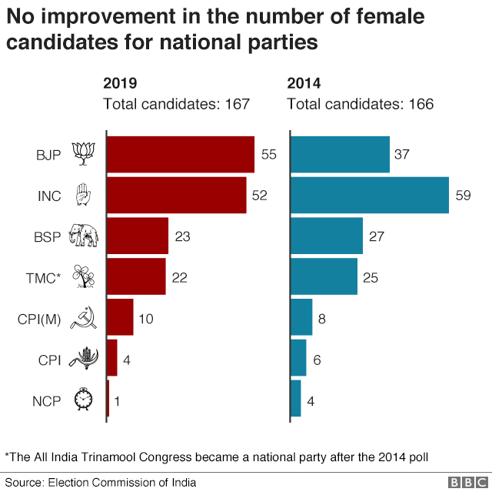

### **Electronic voting machines and security:**

The ECI deployed a total of **1.74 million voter-verified paper audit trail (VVPAT) units** and **3.96 million electronic voting machines (EVM)** in **1,035,918 polling stations**. Approximately **270,000 paramilitary** and **2 million state police personnel** provided organisational support and security at various polling booths.

**Voting:**

In the **first phase**, **69.58 per cent of the 142 million eligible voters cast their vote** to elect their representatives for **91 Lok Sabha seats.** In the **second phase, 156 million voters** were

|  |
| --- |
| **Name: Debarghya Barik**  **Rg. No: RA2011026010022** |

eligible to vote for **95 Lok Sabha seats** and the turnout was 69.45 per cent. For the **third phase, 189 million voters** were eligible to elect **116 Lok Sabha representatives**. In the **fourth of seven phases, 65.50 per cent of the 128 million eligible voters** cast their vote to elect **72 representatives to the Indian parliament** while the turnout for the same seats in the 2014 election was 63.05 per cent. The **fifth phase was open to 87.5 million eligible voters**, who could cast their vote in over 96,000 polling booths. In the **sixth phase**, **64.40 per cent** of the **101 million eligible voters** cast their vote in about 113,000 polling stations.

**The final turnout stood at 67.11 per cent**, the highest ever turnout recorded in any of the general elections till date. The percentage is 1.16 per cent higher than the 2014 elections whose turnout stood at 65.95 per cent. Over 600 million voters polled their votes in 2019 Indian General elections.

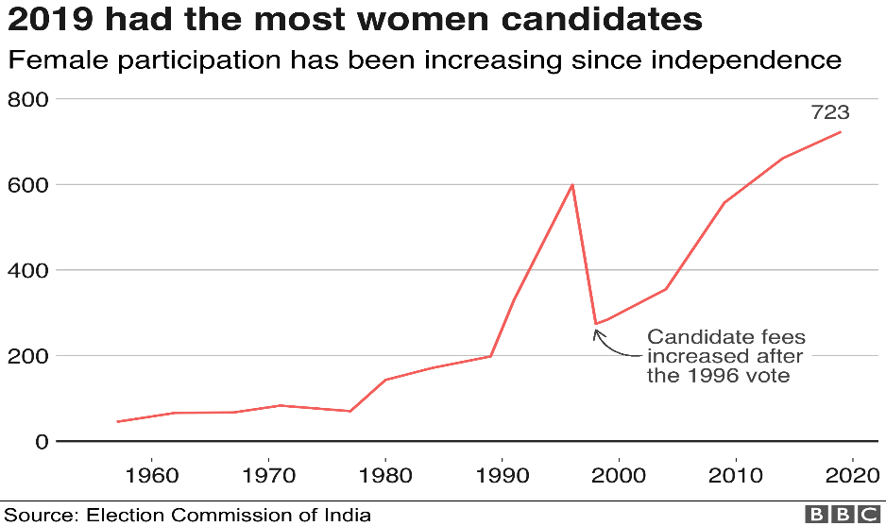

**Voter Turnout:**

| **State/UT** | **Total electors** | **Total voters** | **Total turnout** | **Total seats** |
| --- | --- | --- | --- | --- |
| Andaman & Nicobar Islands (UT) | 318,471 | 207,398 | 65.12% | 1 |
|  | | | | |
|  | | | | |
|  | | | | |
| Bihar | 71,216,290 | 40,830,453 | 57.33% | 40 |
|  | | | | |
|  | | | | |
|  | | | | |
| Daman & Diu (UT) | 121,740 | 87,473 | 71.85% | 1 |
|  | | | | |
|  | | | | |
|  | | | | |
| Himachal Pradesh | 5,330,154 | 3,859,940 | 72.42% | 4 |
|  | | | | |
|  | | | | |
|  | | | | |
| Kerala | 26,204,836 | 20,397,168 | 77.84% | 20 |
|  | | | | |
|  | | | | |
|  | | | | |
| Manipur | 1,959,563 | 1,620,451 | 82.69% | 2 |
|  | | | | |
|  | | | | |
|  | | | | |
|  | | | | |
| Odisha | 32,497,762 | 23,817,169 | 73.29% | 21 |
|  | | | | |
| Punjab | 20,892,673 | 13,777,295 | 65.94% | 13 |
|  | | | | |
| Sikkim | 434,128 | 353,415 | 81.41% | 1 |
|  | | | | |
| Telangana | 29,708,615 | 18,646,856 | 62.77% | 17 |
|  | | | | |
| Uttar Pradesh | 146,134,603 | 86,531,972 | 59.21% | 80 |
|  | | | | |
| West Bengal | 70,001,284 | 57,230,018 | 81.76% | 42 |
|  | | | | |

|  |
| --- |
| **Name: Debarghya Barik**  **Rg. No: RA2011026010022** |

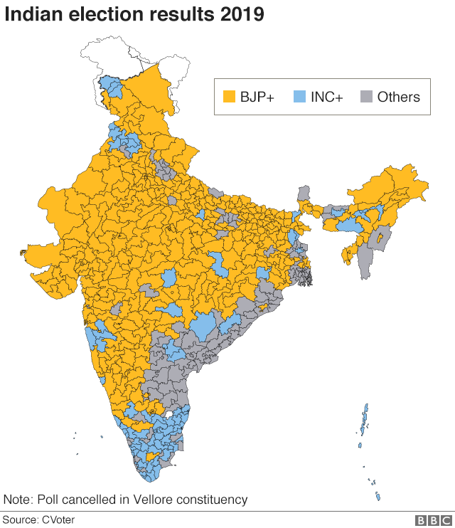

**Aftermath:**

### ***Reactions***

#### **National -** Indian National Congress party leaders such as **Rahul Gandhi** and others **conceded defeat** and **congratulated Modi and his party**. Other opposition parties and political leaders such as **Sharad Pawar** **Mamata Banerjee** and **Omar Abdullah**, congratulated PM Modi and BJP for their victory.

#### **International -** The leaders of [**Afghanistan**](https://en.wikipedia.org/wiki/Afghanistan)**,** [**Argentina**](https://en.wikipedia.org/wiki/Argentina)**,** [**Australia**](https://en.wikipedia.org/wiki/Australia)**,** [**Austria**](https://en.wikipedia.org/wiki/Austria)**,**[**Bahrain**](https://en.wikipedia.org/wiki/Bahrain)**,**[**Bangladesh**](https://en.wikipedia.org/wiki/Bangladesh)**,**[**Bhutan**](https://en.wikipedia.org/wiki/Bhutan)**,**[**Botswana**](https://en.wikipedia.org/wiki/Botswana)**,**[**Brazil**](https://en.wikipedia.org/wiki/Brazil)**,**[**Bulgaria**](https://en.wikipedia.org/wiki/Bulgaria)**,**[**Burundi**](https://en.wikipedia.org/wiki/Burundi)**,**[**Canada**](https://en.wikipedia.org/wiki/Canada)**,**[**China**](https://en.wikipedia.org/wiki/China) and other countries **congratulated**[**Narendra Modi**](https://en.wikipedia.org/wiki/Narendra_Modi)**and the**[**BJP**](https://en.wikipedia.org/wiki/BJP)**on their victory.**

### **Government formation:**

* **23 May 2019**: PM [Narendra Modi](https://en.wikipedia.org/wiki/Narendra_Modi) wins a second term with an overwhelming majority.
* **30 May 2019**: PM [Narendra Modi](https://en.wikipedia.org/wiki/Narendra_Modi) is sworn in as [Prime Minister of India](https://en.wikipedia.org/wiki/Prime_Minister_of_India) with 24 Cabinet Ministers, 9 MoS (Independent Charge) and 24 MoS.

### **Swearing-in ceremony:**

|  |
| --- |
| **Name: Debarghya Barik**  **Rg. No: RA2011026010022** |

[**Narendra Modi**](https://en.wikipedia.org/wiki/Narendra_Modi)**,** parliamentary leader of the [Bharatiya Janata Party](https://en.wikipedia.org/wiki/Bharatiya_Janata_Party" \o "Bharatiya Janata Party), started his tenure after his swearing-in as the **16th**[**Prime Minister of India**](https://en.wikipedia.org/wiki/Prime_Minister_of_India)**on 30 May 2019 in presence of Ram Nath Kovind, the 14th president of India.** Several [other ministers](https://en.wikipedia.org/wiki/Second_Modi_ministry) were also sworn in along with Modi. The ceremony was noted by media for being the first ever swearing-in of an Indian Prime Minister to have been attended by the heads of all [**BIMSTEC**](https://en.wikipedia.org/wiki/BIMSTEC)**countries.**

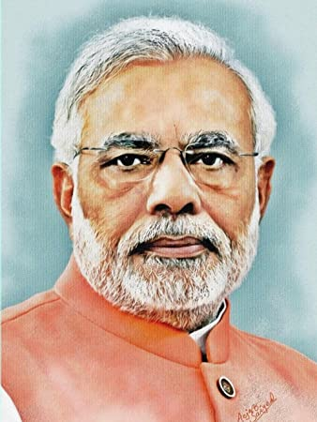

-------------------------------------------------------------X----------------------------------------------------